

Name : Alveena Naz
Reg No. : FA25-BSE-010
PF Assignment 2

Question 1:
import java.util.Scanner;
public class FirstJava
{
public static void main(String[] args)
{
Scanner input = new Scanner(System.in);
System.out.println(" Enter the number of students");
int n = input.nextInt();
input.nextLine();
int highestMarks=0;
String topper = "";
for(int i = 0; i <n; i++)
{
System.out.println(" Enter the name of student");
String name = input.nextLine();
System.out.println(" Enter the marks of " + name);
int marks = input.nextInt();
input.nextLine();
if(marks>highestMarks)
{
highestMarks = marks;
topper = name;
}
}
System.out.println(topper+ " " + highestMarks);
}
}

OUTPUT:
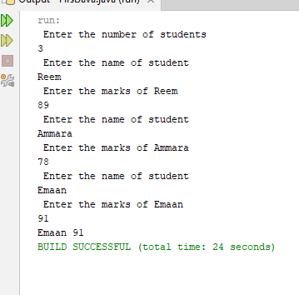

Question 2:
import java.util.Scanner;
public class FirstJava
{
public static void main(String[] args)
{
Scanner input = new Scanner(System.in);
System.out.println(" Enter the number of students");
int n = input.nextInt();
input.nextLine();
String topper = "";
int highestMarks= 0;
String secTopper = "";
int secHighest = 0;
for(int i = 1; i <=n; i++)
{
System.out.println(" Enter the name of student");
String name = input.nextLine();
System.out.println(" Enter the score of " + name);
int score = input.nextInt();
input.nextLine();
if(score>highestMarks)
{
secHighest = highestMarks;
secTopper = topper;

highestMarks = score;
topper = name;
}
else if(score>secHighest && score<highestMarks)
{
secHighest = score;
secTopper = name;
}

}
System.out.println(topper + " " + highestMarks);
System.out.println(secTopper + " " + secHighest);
}
}

Output:
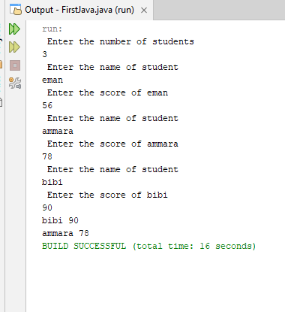

Question 3:

import java.util.Scanner;
public class FirstJava
{
public static void main(String[] args)
{
Scanner input = new Scanner(System.in);

while(true)
{
System.out.println(" Enter an integer value");
int n = input.nextInt();
boolean isPrime = true;
for(int i = 2; i <=n/2; i++)
{
if(n%i==0)
{
isPrime = false;
break;
}

}
if(isPrime)
break;

}
}
}

OUTPUT:
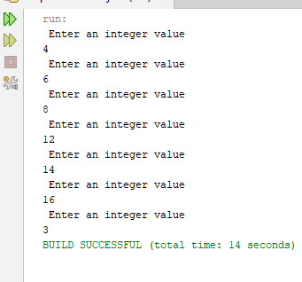

Question 4:
import java.util.Scanner;
public class FirstJava
{
public static void main(String[] args)
{
Scanner input = new Scanner(System.in);
System.out.println(" Enter the number of lines");
int n = input.nextInt();
// left side
for(int i = 0; i <n; i++)
{
//spces
for(int j = 0; j < n-i-1; j++)
{
System.out.print(" ");
}
// numbers
for(int k = i+1; k >0; k--)
{
System.out.print(k + " ");
}
// Right side
//numbers
int num = 2;
for(int j = 0; j <i; j++)
{
System.out.print(num+" ");
num++;
}
System.out.println();

}

}
}

OUTPUT:
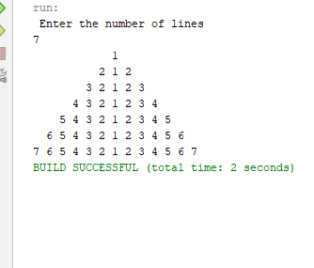

Question 5:
Pattern a:
import java.util.Scanner;
public class FirstJava
{
public static void main(String[] args)
{
Scanner input = new Scanner(System.in);
System.out.println(" Enter the number of lines");
int n = input.nextInt();
for(int i = 1; i <=n; i++)
{
//spces
for(int j = 1; j <= i; j++)
{
System.out.print(j + " ");
}

System.out.println();
}

}
}

OUTPUT:
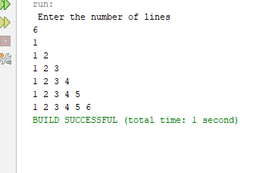

Pattern b:
import java.util.Scanner;
public class FirstJava
{
public static void main(String[] args)
{
Scanner input = new Scanner(System.in);
System.out.println(" Enter the number of lines");
int n = input.nextInt();
for(int i = 0; i <n; i++)
{
for(int j = 0; j <n-i; j++)
{
System.out.print((j+1) + " ");
}

System.out.println();
}

}
}

OUTPUT:
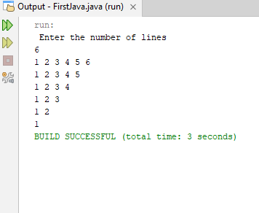

Pattern c:
import java.util.Scanner;
public class FirstJava
{
public static void main(String[] args)
{
Scanner input = new Scanner(System.in);
System.out.println(" Enter the number of lines");
int n = input.nextInt();
for(int i = 0; i <n; i++)
{
for(int j = 0; j <n-i-1; j++)
{
System.out.print(" ");
}
for(int k = i+1; k>0; k--)
{
System.out.print(k+" ");
}

System.out.println();
}

}
}

OUTPUT:
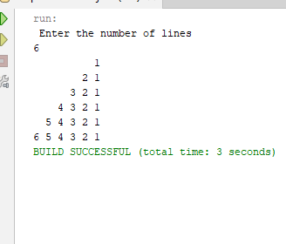

Pattern d:
import java.util.Scanner;
public class FirstJava
{
public static void main(String[] args)
{
Scanner input = new Scanner(System.in);
System.out.println(" Enter the number of lines");
int n = input.nextInt();
for(int i = 0; i <n; i++)
{
for(int j = 0; j <i; j++)
{
System.out.print(" ");
}
for(int k = 0; k<n-i; k++)
{
System.out.print(k+1+" ");
}

System.out.println();
}

}
}

OUTPUT:
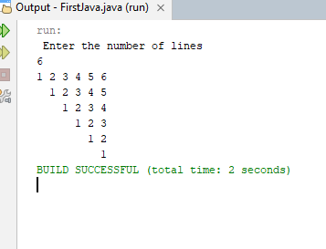

Question 6:
import java.util.Scanner;
public class FirstJava
{
public static void main(String[] args)
{
Scanner input = new Scanner(System.in);
System.out.println(" Enter the number of lines");
int n = input.nextInt();
for(int i = 0; i <n; i++)
{
for(int j = 0; j <n-i-1; j++)
{
System.out.print(" ");
}
int num = 1;
for(int k = 0; k<i+1; k++)
{
System.out.print(num + " ");
num*=2;
}
// Right side
num/=2;
for(int j = i; j>0; j--)
{
num/=2;
System.out.print(num +" ");
}

System.out.println();
}

}
}

OUTPUT:
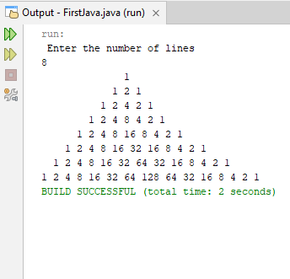

Question 8:
import java.util.Scanner;
public class FirstJava
{
public static void main(String[] args)
{
Scanner input = new Scanner(System.in);
System.out.println(" Enter a decimal number");
int decNum = input.nextInt();
int power = 1;
int answer = 0;
int rem;
while(decNum> 0)
{
rem = decNum%2;
decNum/=2;
answer+=(rem * power);
power*=10;
}
System.out.println(" The binary form is " + answer);

}
}

OUTPUT:
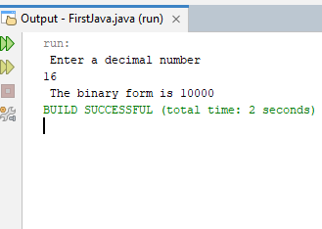

Question 9:
import java.util.Scanner;
public class FirstJava
{
public static void main(String[] args)
{
Scanner input = new Scanner(System.in);
System.out.println(" Enter a string");
String str = input.nextLine();
String reverse = "";
for(int i = str.length()-1; i>=0; i--)
{
char ch = str.charAt(i);
reverse+=ch;

}

System.out.println(" The reverse is " + reverse);

}
}

OUTPUT:
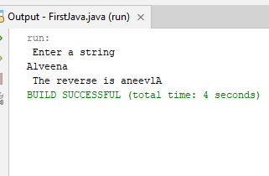

Question 7:
//import java.util.Scanner;
public class FirstJava
{
public static void main(String[] args)
{
//Scanner input = new Scanner(System.in);
int perfectNum= 6;

while(perfectNum<10000)
{
int sum= 0;
for(int i = 1; i<perfectNum; i++)
{
if(perfectNum%i==0)
sum+=i;

}
if(sum==perfectNum)
System.out.println(" Perfect numbers are " + perfectNum);
perfectNum++;
}

}
}

Output:
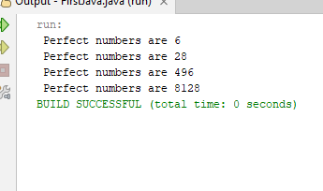

Question 10:
import java.util.Scanner;
public class FirstJava
{
public static void main(String[] args)
{
Scanner input = new Scanner(System.in);
System.out.println(" enter a string ");
String str = input.nextLine();
int vowels= 0;
for(int i = 0; i <str.length(); i++)
{
char ch = str.charAt(i);
char lowerChar= Character.toLowerCase(ch);
if(lowerChar=='a'|| lowerChar=='e'|| lowerChar=='i'|| lowerChar=='o'|| lowerChar=='u')
vowels++;
}
System.out.println(" The numbers of vowels are " + vowels);

}
}

Output:
